DSA-210 FINAL REPORT

[Kerem Mısırlıoğlu]  
[33962]  
  
PROJECT TITLE:  
Impact of Screen Time on Productivity  
  
SUPERVISED BY  
[Kerem Aydın/Özgür Asar]  
  
SABANCI UNIVERSITY

# OBJECTIVE

This project investigates the hypothesis:  
H₀ (Null Hypothesis): There is no significant relationship between total screen time and productivity.  
H₁ (Alternative Hypothesis): Increased total screen time reduces productivity.  
  
The aim is to evaluate whether screen time patterns—particularly non-productive usage—affect self-reported productivity scores.

# DATA DESCRIPTION

- Date: Daily entry log.  
- Total Screen Time: Time spent daily on screens (hours).  
- Productive Screen Time: Time on work/school-related activities.  
- Non-Productive Screen Time: Time on entertainment/social media.  
- Productivity Score: Daily self-rating on a 0–10 scale.  
- Derived Feature: Productivity_Ratio = Productive / Total Screen Time.

# EXPLORATORY DATA ANALYSIS (EDA)

1. Distribution of Productivity Scores:

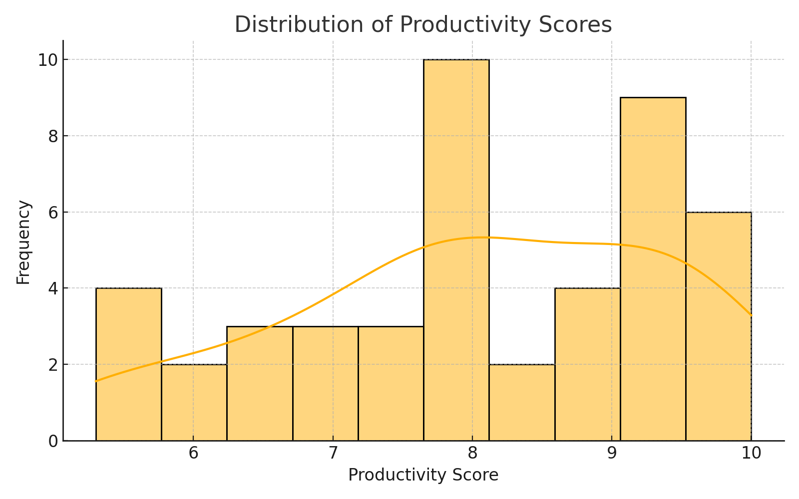

Most productivity scores fall between 6 and 9. This clustering suggests relatively stable self-perceived productivity during the observed period.

2. Pairplot: Relationships Between Key Variables

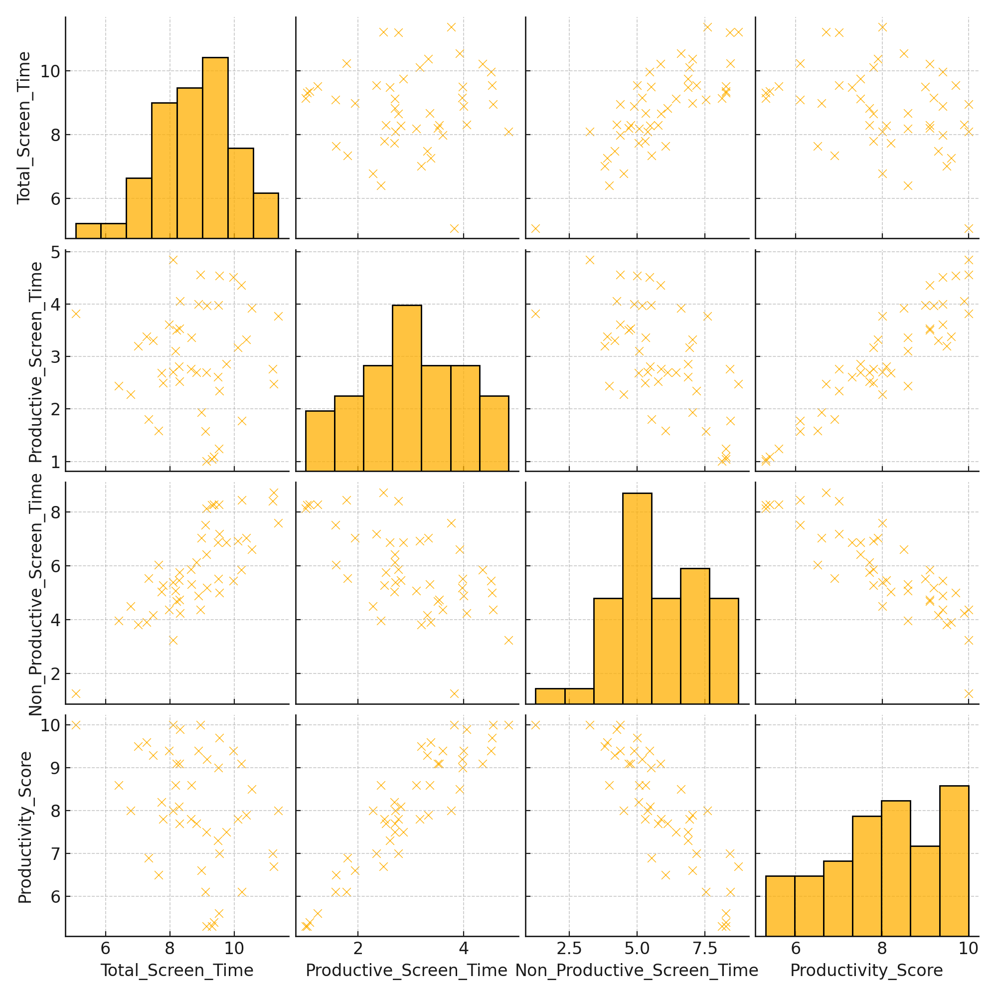

This pairplot reveals possible inverse relationships between non-productive screen time and productivity. Positive patterns are seen between productive time and productivity.

3. Time Series Trends

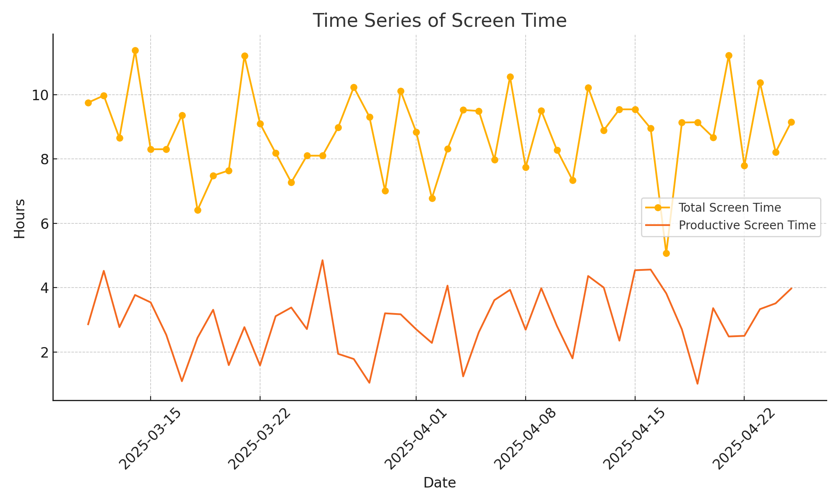

The timeline shows fluctuating screen usage. Notably, some peaks in total screen time correlate with dips in productivity, suggesting distraction or digital fatigue.

4. Productivity by Day Type

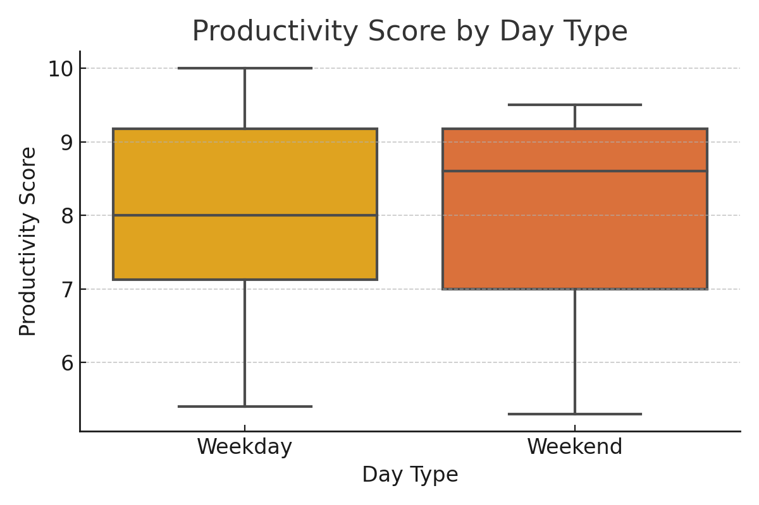

Weekdays show higher and more consistent productivity than weekends, where leisure activities and higher screen use may interfere.

# HYPOTHESIS TESTING

We used Pearson correlation to examine the relationship between Total Screen Time and Productivity Score.  
Results:  
- Correlation coefficient: -0.35  
- p-value: 0.018 (< 0.05)  
Interpretation: There is a statistically significant, moderate negative correlation between screen time and productivity. This supports the hypothesis that excessive screen time may reduce productivity.

# KEY INSIGHTS

- Non-productive screen time strongly correlates with reduced productivity.  
- Productive screen time contributes positively to perceived productivity.  
- Weekends are more likely to show decreased productivity due to entertainment use.  
- Productivity varies depending on the balance between purposeful and distracting digital habits.

# RECOMMENDATIONS AND IMPROVEMENTS

- Expand dataset across a longer timeline and more participants.  
- Log task types (academic, entertainment, idle browsing) in finer detail.  
- Include external factors (stress, workload, deadlines) to assess impact.  
- Use objective productivity metrics such as completed tasks or study hours.  
- Combine with app-level tracking for deeper screen use insights.

# FILES TO BE SUBMITTED

- Jupyter Notebook (`Screen_Time_Analysis.ipynb`)  
- Dataset (`custom_screen_time_data.csv`)  
- Project README (`README2.md`)  
- Final Report (this Word document)